**Addressing the Challenges of Multi-Generational Workforces**

In today's rapidly evolving workplace, the presence of a multi-generational workforce is increasingly common. Employees from different generations bring diverse experiences, skills, and perspectives. While this diversity can drive innovation and creativity, it also presents unique challenges that organizations must address to foster a harmonious and productive work environment. This article explores the challenges and advantages associated with multi-generational workforces and offers strategies for managing them effectively.

**Understanding Generational Differences**

To address the challenges of a multi-generational workforce, it is essential to understand the distinct characteristics of each generation currently in the workplace. The workforce typically comprises four main generations:

1. **Baby Boomers (1946-1964)**: Born in the post-World War II era, Baby Boomers are often characterized by their strong work ethic, loyalty to employers, and desire for job stability. They value face-to-face communication and often prefer hierarchical organizational structures. Many Baby Boomers are also nearing retirement, leading to the potential for significant knowledge transfer or loss.
2. **Generation X (1965-1980)**: This generation grew up during a time of economic uncertainty and is often seen as independent, resourceful, and adaptable. Generation X values work-life balance and tends to be skeptical of authority. They are comfortable with technology but appreciate personal interaction. They often find themselves in managerial roles, bridging the gap between older and younger generations.
3. **Millennials (1981-1996)**: Also known as Generation Y, Millennials are tech-savvy and value collaboration, flexibility, and meaningful work. They seek feedback and opportunities for growth and development. Millennials are known for their preference for digital communication and their desire for a positive work culture. Their aspirations often emphasize personal fulfillment alongside professional achievements.
4. **Generation Z (1997-2012)**: The newest entrants into the workforce, Generation Z, are characterized by their digital fluency and pragmatic approach to work. They value diversity and inclusion, seek job security, and are motivated by a sense of purpose. This generation tends to prefer virtual communication and flexible work arrangements. As they start to enter the workforce, they bring a fresh perspective on work-life integration.

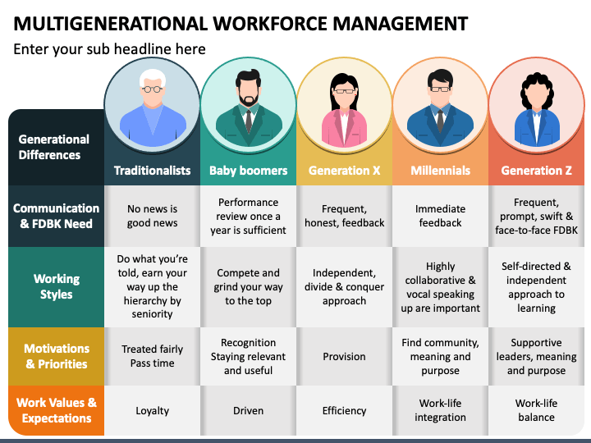

**The Challenges of a Multi-Generational Workforce**

**1. Communication Gaps**

One of the primary challenges in a multi-generational workforce is communication. Different generations have varying preferences for communication styles and channels. Baby Boomers may prefer face-to-face meetings or phone calls, while Millennials and Generation Z are more comfortable with digital communication methods such as instant messaging and emails. These differences can lead to misunderstandings, frustration, and decreased collaboration.

**2. Work Ethics and Values**

Each generation has unique work ethics and values shaped by their formative experiences. For instance, Baby Boomers often prioritize loyalty and long-term commitment to a company, while Millennials and Generation Z value flexibility and work-life balance. This disparity can lead to conflicts regarding expectations around work hours, job commitments, and performance evaluations.

**3. Employee Engagement and Motivation**

Motivating a diverse workforce can be challenging, as different generations may respond to various incentives and recognition methods. While Baby Boomers might value job security and traditional benefits, Millennials and Generation Z may prioritize professional development and work-life balance. Understanding these differences is crucial for creating effective employee engagement strategies.

**4. Technology Adoption**

Technology plays a pivotal role in modern workplaces, but not all generations are equally comfortable with new tools and platforms. Younger employees often adapt quickly to new technologies, while older employees may struggle to keep pace. This can create frustration and hinder productivity if not addressed properly.

**5. Conflict and Misunderstanding**

The differences in values, work ethics, and communication styles can lead to conflicts and misunderstandings among employees. For example, younger generations may perceive older employees as resistant to change, while older generations may see younger employees as lacking commitment. Such tensions can affect team cohesion and overall productivity.

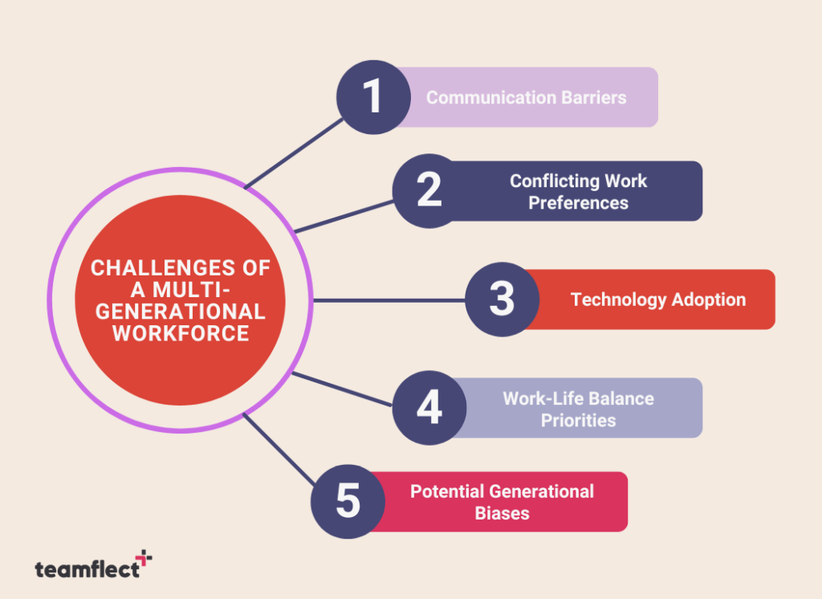

**Advantages of a Multi-Generational Workforce**

While there are challenges, a multi-generational workforce also offers several advantages that can enhance organizational performance and foster a positive workplace culture:

**1. Diverse Perspectives**

Having employees from various generations brings a wealth of diverse perspectives and ideas. This diversity fosters creativity and innovation, as different generations approach problems from unique angles. Organizations can leverage this variety of viewpoints to develop more comprehensive solutions and enhance their overall competitiveness.

**2. Knowledge Sharing and Mentorship**

Multi-generational teams create opportunities for knowledge sharing and mentorship. Older employees can pass down valuable insights and experiences, while younger employees can introduce new technologies and methodologies. This exchange fosters a culture of continuous learning and helps bridge the skills gap that may arise from an aging workforce.

**3. Enhanced Problem-Solving**

Diverse teams are often better equipped to tackle complex problems. The combination of varying experiences, skills, and thought processes allows multi-generational teams to analyze situations from multiple dimensions. This capability can lead to more effective decision-making and improved outcomes.

**4. Improved Employee Engagement**

Organizations that embrace a multi-generational workforce can foster higher levels of employee engagement. By recognizing and valuing the contributions of employees from all generations, organizations can create a sense of belonging and commitment. Engaged employees are more likely to be productive, innovative, and loyal to their employer.

**5. Broader Customer Understanding**

A diverse workforce reflects the diversity of customers and clients in the marketplace. Employees from different generations can provide insights into the needs and preferences of various demographic groups. This understanding can enhance customer service, improve product development, and drive overall business success.

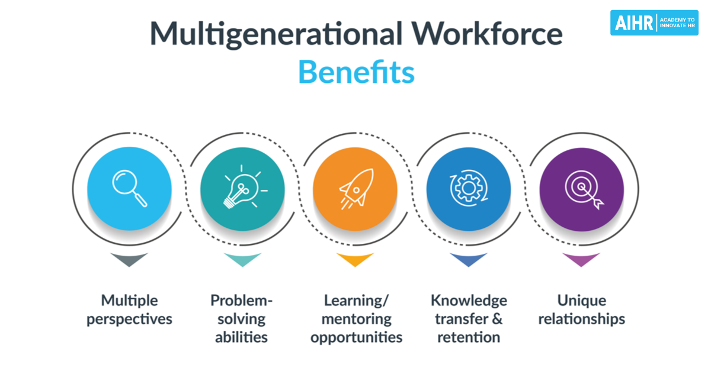

**Strategies for Addressing Multi-Generational Challenges**

To effectively manage the challenges of a multi-generational workforce while harnessing its advantages, organizations can implement several key strategies:

**1. Foster Open Communication**

Creating an environment that encourages open communication is essential for bridging the generational gap. Organizations should implement communication strategies that accommodate different preferences. This may include a mix of traditional and digital communication methods, regular feedback sessions, and team-building activities that promote interaction among employees from different generations.

**2. Promote Collaboration and Inclusivity**

Encouraging collaboration among employees of all generations can help break down silos and foster a sense of community. Implementing cross-generational mentoring programs, where older employees share their knowledge with younger ones and vice versa, can enhance mutual understanding and respect. Inclusivity initiatives that celebrate diversity can also create a more cohesive workplace culture.

**3. Adapt Leadership Styles**

Leaders should adopt flexible leadership styles that can accommodate the diverse needs of their teams. This might involve providing clear direction and support for Baby Boomers while offering Millennials and Generation Z opportunities for autonomy and input in decision-making. Training programs that focus on emotional intelligence and adaptive leadership can help managers navigate these dynamics effectively.

**4. Create a Culture of Learning**

A culture of continuous learning can be beneficial for all generations. Organizations should invest in training and development programs that cater to the diverse learning styles and preferences of their employees. Offering mentorship opportunities, workshops, and online courses can empower employees to grow and develop their skills, fostering a sense of purpose and engagement.

**5. Recognize and Celebrate Achievements**

Recognizing and celebrating the achievements of employees from all generations can foster a sense of belonging and motivation. Organizations should implement recognition programs that acknowledge both individual and team contributions. This can include awards, shout-outs during meetings, or social media recognition. Tailoring recognition methods to suit different generations can enhance their effectiveness.

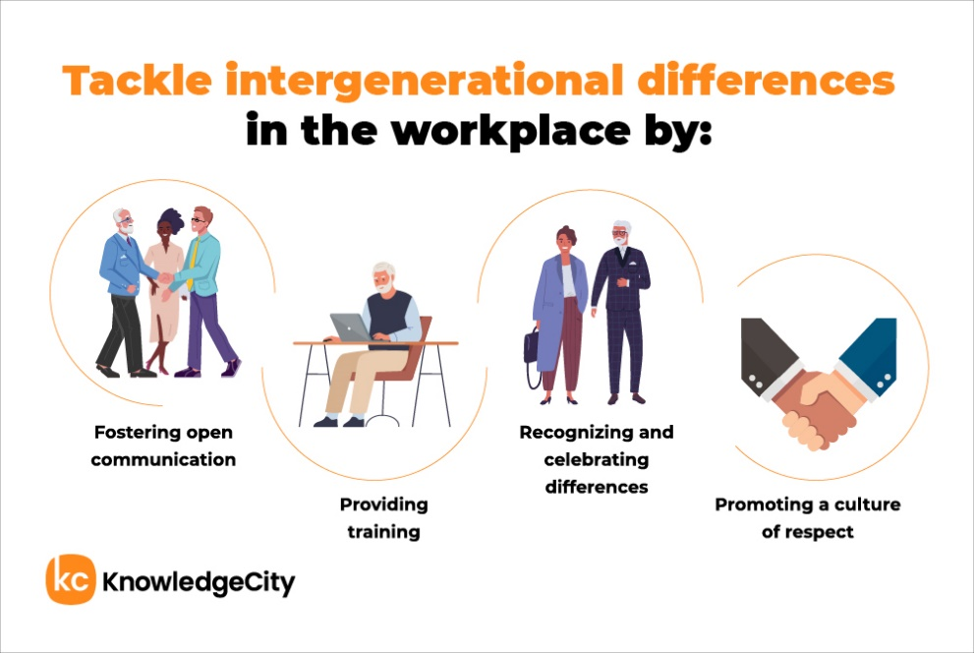

**Conclusion**

As the workforce continues to evolve, addressing the challenges of a multi-generational environment is essential for organizations seeking to thrive in today’s competitive landscape. By understanding the unique characteristics of each generation and implementing strategies that promote open communication, collaboration, and inclusivity, organizations can harness the strengths of a diverse workforce. Embracing the differences among employees will not only foster a positive workplace culture but also drive innovation and success in the long run.

Ultimately, the goal should be to create a workplace where all generations can collaborate effectively, feel valued, and contribute to the organization’s success. Through intentional strategies and a commitment to understanding and embracing diversity, organizations can turn the challenges of a multi-generational workforce into opportunities for growth and innovation. By leveraging the advantages that come with a multi-generational workforce, organizations can position themselves for long-term success in an ever-changing business landscape.

In conclusion, while the challenges of managing a multi-generational workforce are significant, the benefits far outweigh them. Organizations that proactively address these challenges are likely to find themselves more resilient, innovative, and better equipped to meet the demands of an increasingly diverse market. By creating an inclusive environment that values the contributions of every generation, businesses can thrive and achieve their strategic goals while fostering a culture of collaboration and mutual respect.