**Building Resilient Supply Chains in a Post-Pandemic and Geopolitically Uncertain World**

**Introduction**

The COVID-19 pandemic and ongoing geopolitical shifts have exposed vulnerabilities in global supply chains, leading to severe disruptions across industries. These events have underscored the need for resilient supply chains that can adapt to crises, ensuring the steady flow of goods and services even in unpredictable circumstances. Government policies play a pivotal role in strengthening these supply chains by implementing regulations, providing incentives, and fostering innovation. This article explores how government interventions are essential in supporting resilient supply chains and highlights the key areas where policies can make the most significant impact.

**Understanding Resilient Supply Chains**

A resilient supply chain is one that can withstand disruptions, adapt quickly to changes, and recover efficiently from crises. Achieving this requires robust planning, risk management, and a focus on sustainability. Governments, with their ability to influence trade policies, infrastructure development, and technological advancements, are uniquely positioned to support the resilience of supply chains.

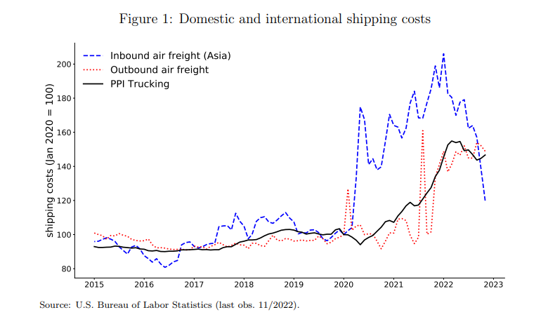

In a post-pandemic and geopolitically uncertain world, supply chain resilience means reducing reliance on a few global suppliers, diversifying sourcing, and investing in digital transformation to enhance visibility and agility.

**Key Areas of Government Policy Impact**

**1. Infrastructure Investment**

Governments play a crucial role in building and maintaining the physical and digital infrastructure necessary for efficient supply chain operations. Ports, roads, railways, and broadband networks are essential for the smooth movement of goods and information.

By investing in infrastructure modernization, such as upgrading ports and introducing smart logistics solutions, governments can reduce bottlenecks, improve supply chain efficiency, and facilitate faster recovery from disruptions.

**2. Trade Policies and Diversification**

Governments can promote resilient supply chains by creating favorable trade policies that encourage diversification of suppliers and trade partners. The pandemic exposed the dangers of over-reliance on a few geographic regions for critical goods like semiconductors, pharmaceuticals, and medical equipment.

Through strategic partnerships and trade agreements, governments can foster collaboration between countries with complementary strengths, ensuring more stable and diverse supply networks.

**3. Workforce Development and Automation**

Ensuring a skilled workforce is essential for supply chain resilience. Governments can support workforce development through education and training programs that focus on logistics, automation, and digital skills. Encouraging the adoption of automation in warehouses and factories can also help reduce dependency on manual labor, mitigating the impact of labor shortages during crises.

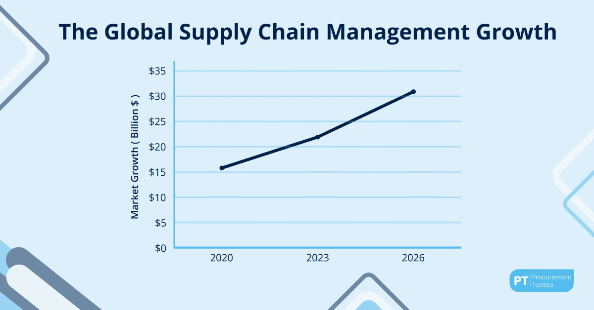

**4. Research and Development (R&D) Incentives**

Innovation is at the heart of resilient supply chains. Governments can stimulate research and development in key areas such as artificial intelligence, blockchain, and IoT to enhance supply chain visibility, predict potential disruptions, and create more efficient operations.

By offering tax breaks or direct funding for R&D, governments can accelerate technological adoption, helping companies anticipate and respond to crises more effectively.

**5. Risk Mitigation and Contingency Planning**

Risk mitigation is central to building resilient supply chains. Governments can mandate risk assessments for critical industries, require stockpiling of essential goods, and promote public-private partnerships to ensure preparedness for future crises.

Early warning systems, such as those for natural disasters or geopolitical instability, can also be established to alert companies of impending disruptions, allowing for proactive measures.

**6. Sustainability and Climate Resilience**

Sustainability is becoming increasingly intertwined with supply chain resilience. Climate change poses long-term risks to global supply chains, from extreme weather events to resource scarcity. Governments can enact policies that encourage sustainable practices, such as reducing carbon emissions, using renewable energy, and promoting the circular economy.

By fostering green logistics and sustainability initiatives, governments help companies not only build more resilient supply chains but also contribute to broader environmental goals.

**Challenges of Implementing Government Policies**

While government policies are essential for creating resilient supply chains, several challenges must be addressed:

* **Coordination Across Borders:** International supply chains require coordination between multiple governments, which can be difficult due to differing regulations and priorities.
* **Cost of Infrastructure and Technology Upgrades:** Building resilient infrastructure and adopting new technologies can be costly, especially for small and medium-sized enterprises (SMEs).
* **Balancing Security and Trade:** While diversifying trade can improve resilience, it can also complicate trade relations and increase costs if not managed carefully.

**The Future of Resilient Supply Chains**

As governments continue to adapt to the new challenges of a post-pandemic and geopolitically uncertain world, the future of supply chains will likely be characterized by greater localization, enhanced digitalization, and increased emphasis on sustainability. Technologies such as artificial intelligence, blockchain, and 5G will further enable supply chains to become more agile and transparent.

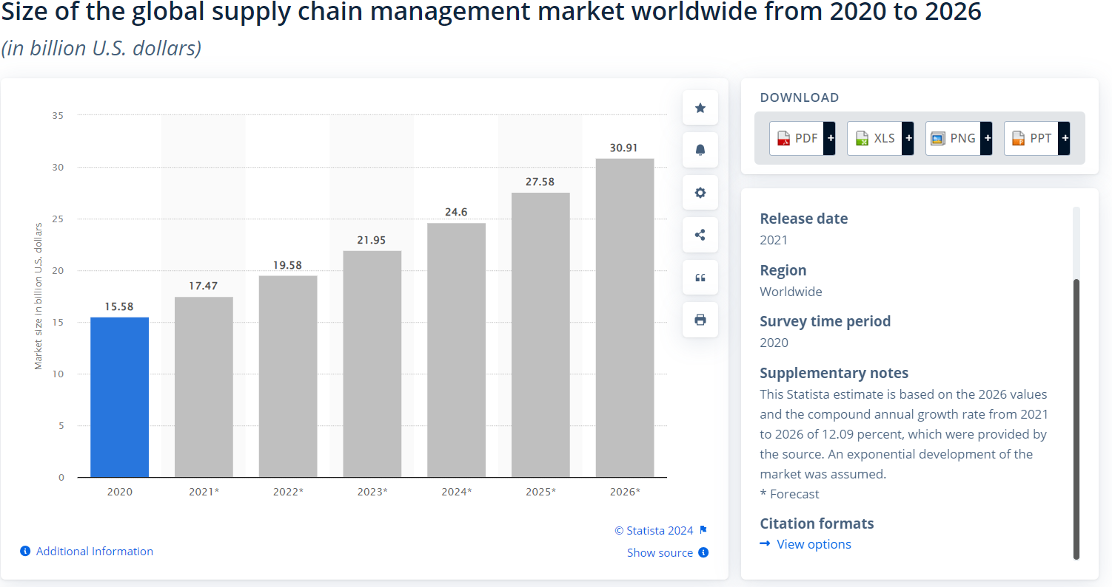

By fostering strong partnerships between public and private sectors, governments can play a leading role in creating supply chains that are not only resilient but also adaptive to the challenges of the 21st century.

**Conclusion**

In conclusion, resilient supply chains are critical for maintaining economic stability in a world of uncertainty. Governments, through infrastructure investments, trade policies, workforce development, and sustainability initiatives, have the power to shape supply chains that can weather crises and thrive in challenging conditions. Moving forward, the collaboration between businesses and policymakers will be key to ensuring that supply chains are both resilient and sustainable in the long term.